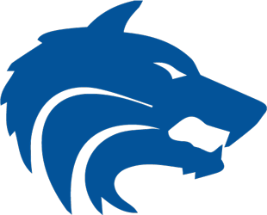

**2022 Running Wolves XC Schedule**

**Date Meet Site**

Aug 13, Saturday Plano ISD XC Invitational Russell Creek Park / Plano

(all athletes will run JV)

Aug 19, Friday Rockhill Twilight 2mi XC Warren Park / Frisco

Aug 27, Saturday Southlake Invitational Bob Jones Park/Southlake

Sept 3, Saturday Marcus I Invitational North Lakes Park / Denton

Sept 10, Saturday Bronco Stampede Myers Park/McKinney

Sept 17, Saturday Lovejoy XC Fall Festival Myers Park, McKinney

Sept 24, Saturday Garmin/MileSplit Invitational South Lakes Park/Denton

Sept 29, Thursday Race at the Lake Lynn Creek Park /Grand Prairie

(Non-qualifiers/JV only)

Oct 1, Saturday Chile Pepper Festival Fayetteville, AR (Univ of Ark)

(Must qualify to travel/compete)

Oct 15, Saturday District 6-6A North Lakes Park

Oct 24, Monday Region 1-6A Mae Simmons Park/ Lubbock

Nov 5, Saturday UIL State Meet Old Settlers Park/Round Rock

Nov 19, Saturday NXR South Bear Branch Park / The Woodlands

(Must qualify to travel/compete)

**Coaches*: Sean Fairchild |*** [***sean.fairchild@pisd.edu***](mailto:sean.fairchild@pisd.edu) ***Bob Molyet* |** [***bob.molyet@pisd.edu***](mailto:bob.molyet@pisd.edu)